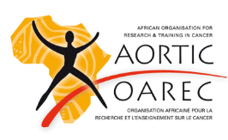
African Cancer Leaders Institute
Institut Africain des Leaders en Cancérologie
2019 Application Form

Part 1: Candidate Information

 | Name
 | Title
 | Institution/Organisation
 | Street
 | City
 | Country
 | Postal Code
 | Email
 | Work Phone (with international dialling code)
 | Mobile Phone(with international dialling code)
Education  (In order of study, most recent to earliest) | Institution
 | Years of Study
 | Degree(s) received
 | Institution
 | Years of Study
 | Degree(s) received
 | Institution
 | Years of Study
 | Degree(s) received
 | Institution
 | Years of Study
 | Degree(s) received
Employment  (In order from most recent to earliest position) | Institution
 | Years of Employment
 | Position Title
 | Institution
 | Years of Employment
 | Position Title
 | Institution
 | Years of Employment
 | Position Title
 | Institution
 | Years of Employment
 | Position Title
Part 2: Professional Qualifications (Include only the most relevant recent activities)
Honours and Awards | Award (Year conferred)
 | Award (Year conferred)
 | Award (Year conferred)
 | Award (Year conferred)
 | Award (Year conferred)
 | Award (Year conferred)
 | Award (Year conferred)
Academic and Volunteer Positions (e.g., board memberships, editorial or grant reviews, academic committees, community activities, government interactions). | Position (Year(s) served)
 | Position (Year(s) served)
 | Position (Year(s) served)
 | Position (Year(s) served)
 | Position (Year(s) served)
 | Position (Year(s) served)
 | Position (Year(s) served)
 | Position (Year(s) served)
 | Position (Year(s) served)
 | Position (Year(s) served)
Prior Non-Degree Training Experiences (e.g., Short-term advocacy, education, research, or leadership training). | Training Programme (Years)
 | Training Programme (Years)
 | Training Programme (Years)
 | Training Programme (Years)
 | Training Programme (Years)
Grant Funding History | Grant Name, Funding Agency, Years
 | Grant Name, Funding Agency, Years
 | Grant Name, Funding Agency, Years

Part 3: Applicant Statements (250 words or less each)
Narrative Career History: What experiences have led you to have an interest in developing cancer leadership activities in Africa?

Potential Contributions to Cancer in Africa: What can you contribute to improved cancer research, education, training, clinical practice, advocacy, or policy in Africa?
Potential Contributions to AORTIC: What can you contribute to the development of AORTIC activities?*

*Information about AORTIC activities can be found on the AORTIC website:
http://www.aortic-africa.org/

Part 4: Recommendation
One recommendation is required from the candidate’s current mentor, supervisor, or other senior official who is familiar with the candidate and their potential for developing leadership activities. Please use the “Recommender Form” on the following page.

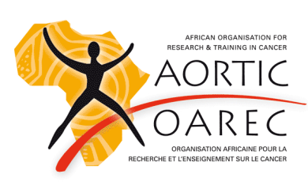
African Cancer Leaders Institute Recommender Form

Instructions to the Recommender: please complete all four parts of this form and return to info@aortic-africa.org before 31 March 2019. The information provided here is confidential and will not be shared with the applicant.

Part A: Please provide the following information about you:
Name
Title
Institutional Affiliation
Contact Phone Number (with dialling codes)
Email
Signature Date

Part B: Please complete the following:
How long have you know the applicant?
In what capacity do you know the applicant? Professor Academic Advisor
Mentor Job Supervisor
Other (Specify):
How well do you know the applicant? Very Well Moderately Well
Minimally Not At All
Please rank this applicant among individuals with whom you have worked with in the past: Top 1% Top 5% Top 10% Top 20% Top 50% Lower 50%

Part C: Please give your impression of the applicant using the checklist below:
 | Excellent | Above Average | Average | Below Average | Poor | Unable to Assess
Interpersonal skills
Oral communication
Written communication
Leaders
Maturity
Potential to develop and implement programmes

Part D: Letters of recommendation are particularly helpful in the acceptance process. Please provide a letter, on your professional stationery, which provides additional detail on your response to Parts B and C above, as well as your comments on the applicant’s promise in becoming a leader for some aspect of cancer (research, education, advocacy, etc.) in Africa.

